**Blast and Dash Game Proposal**

**Rye George**

**CS201 Assessment 1**

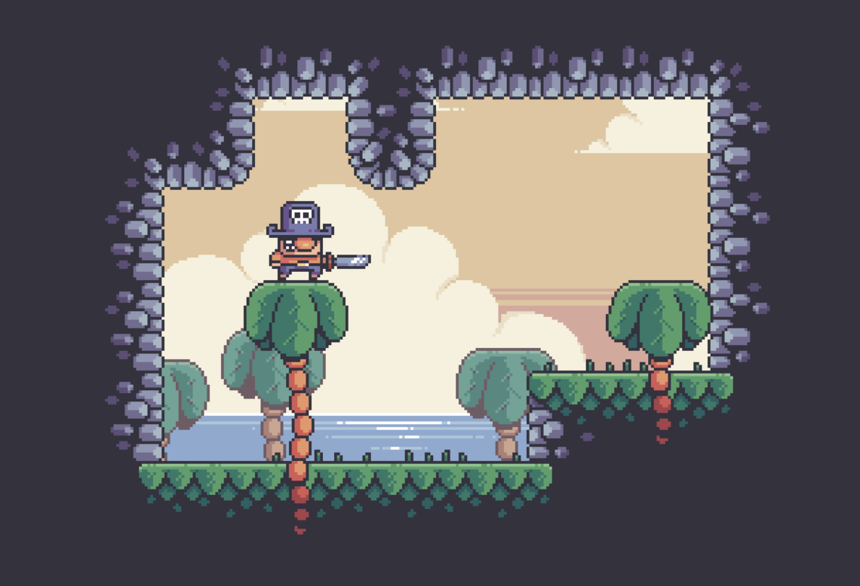

**Table of Contents**

**Executive Summary** 2

**Mission Statement** 2

**High Concept** 2

**Unique Selling Points** 2

**Project Parameters** 3

**Constraints** 3

**Project Duration** 3

**Due Date** 3

**Engine** 3

**Target Platforms** 3

**Target Hardware** 4

**Primary Programming Language** 4

**Team Size** 4

**Project Methodology** 4

**Budget** 4

**Software and Tools** 4

**Target Audience** 4

**Gameplay Overview** 5

**Enemies** 6

**Traps** 7

**User Interface** 8

**Conclusion** 11

# **Executive Summary**

This document will go over the concept and game design of the proposed game “Blast and Dash”.

The games concept will be provided, and all the game features will be explained in detail.

The games target audience and unique selling points will be discussed, along with all the project constraints.

Finally, concepts for the games UI will be provided along with philosophy behind the UI design.

# **Mission Statement**

Our goal is to develop and create a fun, engaging game that will deliver a combination of fast paced platforming and high intensity combat.

# **High Concept**

Blast and Dash is a fast-paced 2D platformer where the player takes on the role of a pirate who has been stranded on a deserted island. They must use their various abilities to traverse the island and find the four torn map pieces in order to escape the island.

But it won’t be easy as there are many dangers on the island. The player must defeat their enemies and avoid the numerous traps in order to reach their goal.

# **Unique Selling Points**

The game contains a couple of core features that the game is based around.

* The player can increase their momentum by chaining movement abilities together.
* The players primary weapon acts as a weapon and a movement ability.

All the game’s features will try and contribute to these core features.

The games target audience is also based on these core features, other games with similar core features have been studied in order to attract our target audience to this game.

# **Project Parameters**

## **Constraints**

* + The project will be constrained by various factors. These include but are not limited to, the project duration, the project budget, and the number of team members working on the project. These factors will be discussed later in this section of the document.

## **Project Duration**

* + The project will start on 26/03/23 and will be finished by 23/04/23, lasting four weeks.

## **Due Date**

* + The due date for the project is 23/04/23.

## **Engine**

* + The game will be developed using the Unity game engine. Unity provided a variety of features that make the development of 2D platformers much easier. This will help us develop the game within the provided time frame.

## **Target Platforms**

* + The target platform for our game is the PC. Platformer games are most popular on PC, and this is where our target audience is.

## **Target Hardware**

* + The game will be optimized to ensure that it can run on any PC. The player will be able to run the game on almost any hardware.

## **Primary Programming Language**

* + The game will be developed using C#. C# is the primary programming language used within Unity.

## **Team Size**

* + The game will be developed by a single developer. This developer will be responsible for the games programming, design, and art.

## **Project Methodology**

* + The project will use an agile development methodology.

## **Budget**

* + The budget for the project is $6000. 30 hours of development a week, for 120 hours, with a developer salary of $50.00 per hour.

## **Software and Tools**

* + The project will use various software and tools throughout the project. Below is a list of these software and tools:
    - Unity Game Engine
    - Visual Studio
    - Git / GitHub

## **Target Audience**

* + Our target audience is based on the audience of other similar games in our genre. Some of these games are Super Meat Bot, Celeste, and Ori and The Blind Forest. Some aspects of these games that our target audience enjoy are:
    - Satisfying movement.
    - Responsive controls.
    - Clear art design

The game has been designed and will be developed based on what our target audience enjoy.

# **Gameplay Overview**

The game will include a variety of gameplay features that will contribute to the core idea of the game.

These features are:

* Wall jumping.
  + The player will be able to jump off walls, giving them an extra boost in momentum and allowing them to reach higher places.
* Wall sliding.
  + While the player is against a wall, they will slide down it. This features pairs well with wall jumping as the player will be able to slide down a wall and then wall jump once they have reached the desired position.
* Dashing
  + By pressing the left shift button, the player will gain a boost of momentum and be pushed forward. This feature will help the player traverse the games level easier, for example the player will be able to jump gaps by dashing that would be too far by only jumping.
* Shotgun
  + The player will have a shotgun. This shotgun will have two uses, as a weapon, and for movement. By shooting the shotgun the player will launched in the opposite direction of the shotgun. This helps make sure that the games combat works with the games core idea of movement and momentum. The shotgun will also be the primary weapon in the game.

All these features contribute to the games core concept of movement-based gameplay. Every gameplay mechanic will be used in some way to keep the player moving as much as possible.

Even the players weapon contributes to this concept, as it can be used as a movement tool and will give the player a momentum boost.

# **Enemies**

Blast and Dash will feature two enemies.

The first enemy is the crab. The crab is the basic enemy of the game, it will move back and forth along a set path and will attack the player once in range.

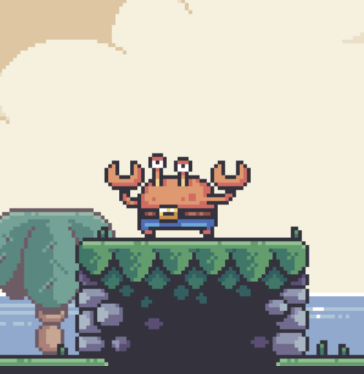

The other enemy is the starfish. The starfish is similar to the crab but for its attack it will dash towards the player. The player will need to keep their distance in order to not be hit by its attack.

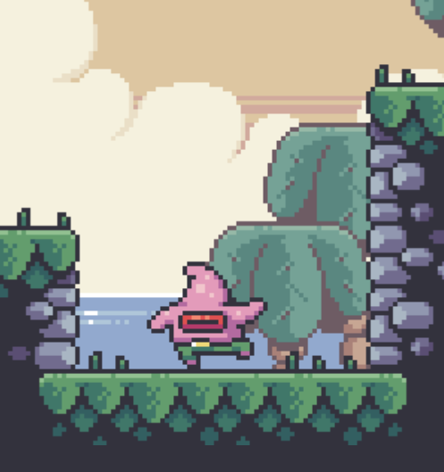

# **Traps**

In addition to the game’s enemies, the island of Blast and Dash is host to numerous deadly traps that the player will need to avoid in order to reach their goal.

The games first trap is the spike. This simple trap will damage the player when the spike is stepped on. This trap will help create more interesting levels and platforming challenges, as the player will need to be careful where they step.

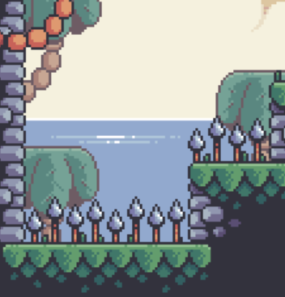

Blast and Dash will also feature a ranged trap. The clam is a ranged trap that will shoot a pearl at the player. But the player will need to keep their distance and attack the clam from afar because if they get too close the clam will perform a melee attack.

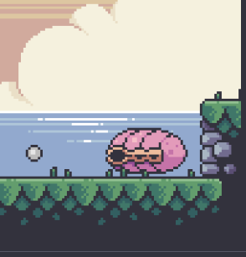

# **User Interface**

The layout of the games UI will use only what is necessary and try to keep the design as minimalist as possible.

The focus of the game should be on the player, and the gameplay. The UI should be a way to provide information to the player. Overloading the player with information can lead to a bad game experience and confusing gameplay.

By default, the only UI element visible to the player will be their healthbar, as this is the only information needed by the player at the time.

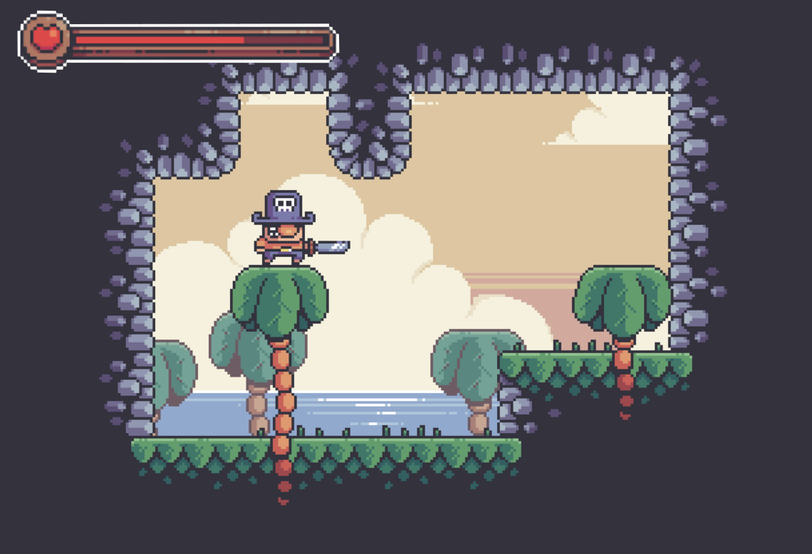

Enemies will have a health bar that displays once they are hit. Before the player hits the enemy, no health bar will be displayed.

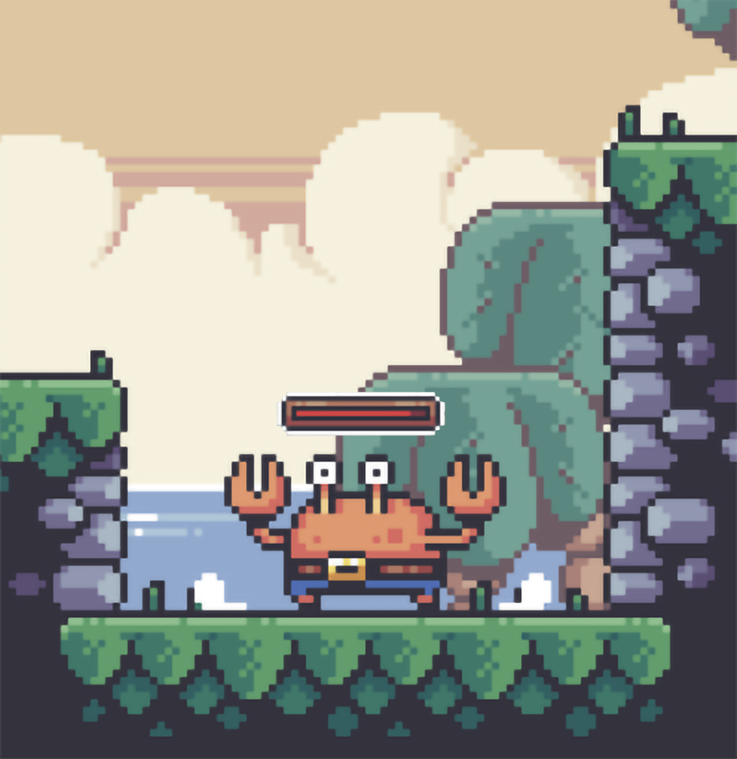

These UI elements are the only elements visisble to the player during regular gameplay.

The games main menu will have an animated background in order to add some life into the menu.

There will be three buttons on the main menu. The strart button which will load the game.

the settings button that will open a second menu and let the player adjust various settings for the game including volume, and a music toggle.

And lastly the quit button will close the game.

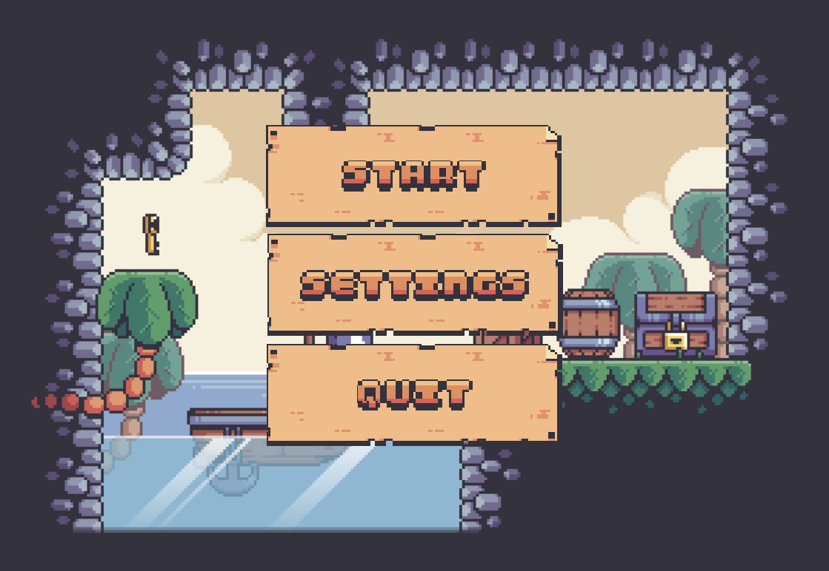

The games pause menu will be the same menu in the main menu, except the start button will be replaced with a continue button.

The continue button will unpause the game when selected. Alternitively the player can unpause the game by presseing the same button they used to pause it.

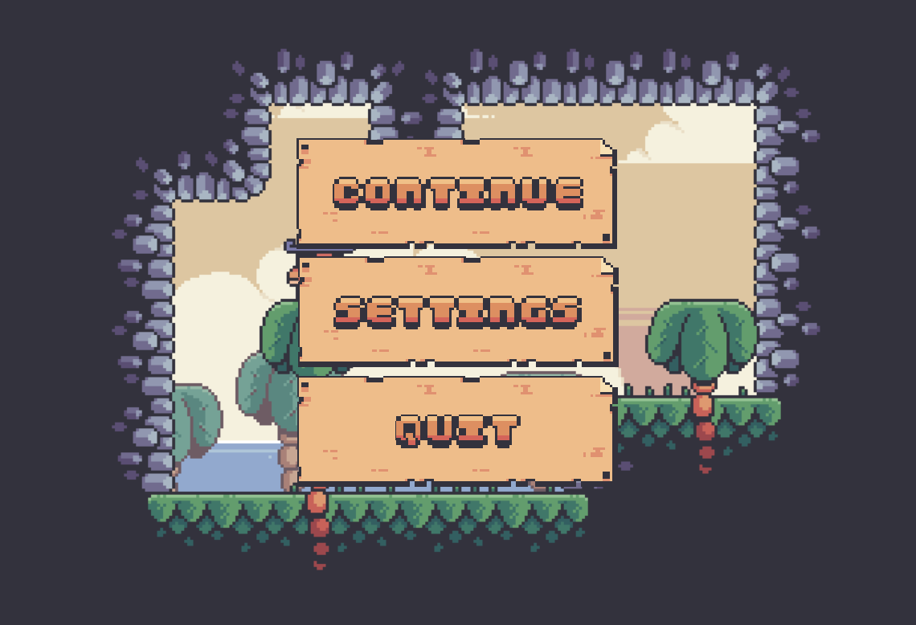

# **Conclusion**

Blast and Dash is fast paced 2D platformer where the player takes on the role of a pirate.

The players weapon acts as a weapon, and a movement ability. This and the other various movement abilities the player has will help set this game apart from other 2D platformers.

The games UI will remain simple in order to avoid a complicated and confusing user experience, while still providing all the required information to the player.

The development of Blast and Dash will start immediately after the approval of this proposal.

*Treasure Hunters by Pixel Frog*. (n.d.). itch.io. https://pixelfrog-assets.itch.io/treasure-hunters